AI-Augmented Backend Development
Project :
TITLE : AI FitTrack – Personalized Fitness Recommendations Powered by AI
Project Description :
AI FitTrack is a secure, full-stack, AI-powered fitness application developed to help users manage their workout activities and receive intelligent fitness guidance through a single web-based platform. The application combines workout tracking, workout history management, workout search, AI-powered recommendations, fitness insights, and a dedicated fitness chatbot.
The frontend of AI FitTrack is developed using React with Vite, providing an interactive interface for both User and Admin roles. The backend is built using Node.js and Express.js, which provides RESTful APIs for authentication, workout management, AI functionality, chatbot interaction, and administrative monitoring. MongoDB is used as the primary database, while Mongoose is used for schema definition, validation, relationships, and database operations.
AI FitTrack provides secure authentication using JSON Web Tokens (JWT), while user passwords are protected using bcrypt.js before being stored in the database. Authenticated users can view their profile, create workout records, view workout history, retrieve individual workouts, update and delete workouts, and search previous workout records.
The application integrates Google Gemini to provide three major AI-powered features: Workout Recommendation, Fitness Insights, and the Gemini Fitness Chatbot. Workout Recommendation generates personalized fitness guidance based on user-provided fitness information, Fitness Insights analyzes recorded workout activity and generates useful observations, and the Gemini Fitness Chatbot provides fitness-focused workout guidance, motivational support, and safety-related assistance.
AI FitTrack also supports an Admin role with read-only monitoring functionality. The Admin can access the Admin Dashboard, Users, Workout Monitoring, Reports & Analytics, and System Health sections to view application-level information without modifying users' personal workout records.
The application follows a modular architecture that separates the frontend, backend routes, controllers, middleware, services, database models, and Google Gemini integration. This structure improves code organization, security, maintainability, and scalability while providing a complete fitness tracking and AI-assisted guidance platform.

Scenario :

Background :
Rahul is a fitness enthusiast who performs workouts regularly but finds it difficult to maintain all of his workout information in one place. He currently records workout details manually using notes and spreadsheets, which makes it difficult to review previous workouts, search workout history, and monitor his overall fitness activity.

He also finds it challenging to decide which workouts are suitable for his fitness goal, age, and experience level. Although he has access to general fitness information online, the guidance is not personalized according to his requirements.

Using AI FitTrack, Rahul can securely register and log in to the application, maintain his workout records, search previous workouts, update or delete workout information, and view his fitness activity through the web interface. He can also use the AI Workout Recommendation feature to receive personalized workout guidance and the Fitness Insights feature to understand his recorded workout activity.

When Rahul requires additional fitness-related assistance, he can interact with the Gemini Fitness Chatbot to receive workout guidance, exercise suggestions, motivational support, and fitness safety information.

At the same time, an authorized Admin can use the Admin Dashboard to monitor users, workout activity, reports and analytics, and system health through the application's read-only administrative features.

System Requirements :

To ensure smooth development, deployment, and usage of the AI FitTrack application, the following system prerequisites must be met.

Operating System

● Windows 10/11

The current AI FitTrack development environment is based on Windows.

Node.js (v18 or above)

Provides the runtime environment for the Node.js + Express.js backend and supports the React/Vite frontend development environment.

The current development environment uses Node.js v24.18.0.

npm (v8 or above)

Package manager used for installing project dependencies and running application scripts such as:

● npm install
● npm run dev
● npm start
● npm run build

The current development environment uses npm v11.16.0.

Express.js

Backend framework used for REST API development, routing, middleware integration, authentication, workout management, AI functionality, chatbot requests, and administrative APIs.

React + Vite

React is used to develop the AI FitTrack frontend user interface, while Vite provides the frontend development and build environment.

The frontend includes:

● User Registration and Login
● User Dashboard
● User Profile
● Workout Management
● Workout Search
● AI Workout Recommendation
● Fitness Insights
● Gemini Fitness Chatbot
● Admin Dashboard
● Users
● Workout Monitoring
● Reports & Analytics
● System Health

MongoDB Community Server

MongoDB is the primary NoSQL database used by AI FitTrack.

The current development environment uses a local MongoDB server.

MongoDB stores:

● User accounts
● User roles
● Authentication-related user information
● Workout records
● User-to-Workout relationship data

The primary application collections are:

● Users Collection
● Workouts Collection

MongoDB Compass

MongoDB Compass is used as the graphical interface for viewing and managing the AI FitTrack MongoDB database.

MongoDB Compass is used to:
● View databases and collections
● Inspect User documents
● Inspect Workout documents
● Verify stored application data
● Check database records during development and testing
● Monitor the local AI FitTrack database

It provides:
● Schema definition
● Data validation
● User Model
● Workout Model
● Database queries
● CRUD operations
● User-to-Workout relationship management
● Automatic timestamps

Authentication and Security
AI FitTrack uses:
● JSON Web Token (JWT) for authentication
● bcrypt.js for password hashing
● Authentication middleware for protected routes
● Role-based authorization for Admin functionality
JWT is used to verify authenticated requests, while bcrypt.js protects user passwords before they are stored in MongoDB.

AI Service Provider
Google Gemini API
Google Gemini provides the AI-powered functionality of AI FitTrack.
It is used for :
● AI Workout Recommendation
● Fitness Insights
● Gemini Fitness Chatbot
Gemini requests are processed through the backend so that the API credential is not directly exposed through the frontend.

Environment Configuration
Environment variables are used to store application configuration and sensitive credentials.Important configuration values include:
● PORT
● MONGO_URI
● JWT_SECRET
● GEMINI_API_KEY

Example :
PORT=5000
MONGO_URI=mongodb://127.0.0.1:27017/aifittrack
JWT_SECRET=your_jwt_secret
GEMINI_API_KEY=your_gemini_api_key
Actual secret values should not be included in public documentation or committed to GitHub.
Other Backend Libraries
The backend uses supporting libraries including:
● express
● mongoose
● dotenv
● cors
● bcryptjs
● jsonwebtoken
● nodemon — development dependency

Frontend Technologies
The frontend uses:
● React
● Vite
● JavaScript
● HTML
● CSS
● React Router

Browser
A modern web browser is required to access and test AI FitTrack.
● Google Chrome
● Microsoft Edge
● Mozilla Firefox
Postman / API Testing
Postman and PowerShell REST requests can be used for API testing.
Testing covers:
● Authentication APIs
● Profile API
● Workout CRUD APIs
● Workout Search
● AI Workout Recommendation
● Fitness Insights
● Gemini Fitness Chatbot
● Admin APIs
● System Health

Visual Studio Code

Visual Studio Code is used as the primary development environment.

It is used for:

● Frontend development
● Backend development
● Source-code editing
● Terminal execution
● Debugging
● Git operations
● Project file management

Git & GitHub

Git is used for source-code version control, while GitHub is used to maintain and manage the AI FitTrack project repository.

2. Hardware Requirements

The AI FitTrack project is currently developed and tested using a Lenovo LOQ laptop with the following hardware configuration.

Laptop

Lenovo LOQ

The Lenovo LOQ provides the hardware environment required to run the frontend, backend, MongoDB database, development tools, and browser simultaneously.

Processor

AMD Ryzen 7

The AMD Ryzen 7 processor provides sufficient multi-core processing capability for running:

● React/Vite frontend
● Node.js/Express backend
● MongoDB
● MongoDB Compass
● Visual Studio Code
● Web browser
● API testing tools

RAM

24 GB RAM

The current development laptop is equipped with 24 GB RAM.

This memory capacity supports smooth multitasking while simultaneously running:

● React/Vite development server
● Node.js/Express backend server
● MongoDB database
● MongoDB Compass
● Visual Studio Code
● Web browser
● API testing tools
● Git development utilities

Graphics

NVIDIA GeForce RTX 3050

The Lenovo LOQ is equipped with an NVIDIA GeForce RTX 3050 GPU.

The graphics processor supports the overall graphical workload and development environment.

AI FitTrack uses the Google Gemini API for AI processing; therefore, Gemini models are not executed locally on the RTX 3050.

Storage

Recommended Free Space: 5 GB or above

Storage is required for:

● AI FitTrack source code
● node_modules
● npm packages
● MongoDB database files
● Frontend build files
● Git repository files
● Screenshots
● Project documentation

Internet Connection

An active internet connection is required for:

● Google Gemini API communication
● npm package installation
● GitHub operations
● Dependency installation and updates

The React frontend, Node.js/Express backend, authentication, workout management, and MongoDB database can operate locally.

However, Gemini-powered AI features require internet connectivity.

Display

Recommended Resolution: 1366 × 768 or above

A modern laptop display is sufficient for development and testing of AI FitTrack and provides workspace for:

● Visual Studio Code
● AI FitTrack frontend
● MongoDB Compass
● Browser Developer Tools
● API testing tools
● Terminal operations

Current Hardware Configuration

● Laptop: Lenovo LOQ
● Processor: AMD Ryzen 7
● RAM: 24 GB
● Graphics: NVIDIA GeForce RTX 3050
● Operating System: Windows 10/11

Project Architecture

Technical Architecture :

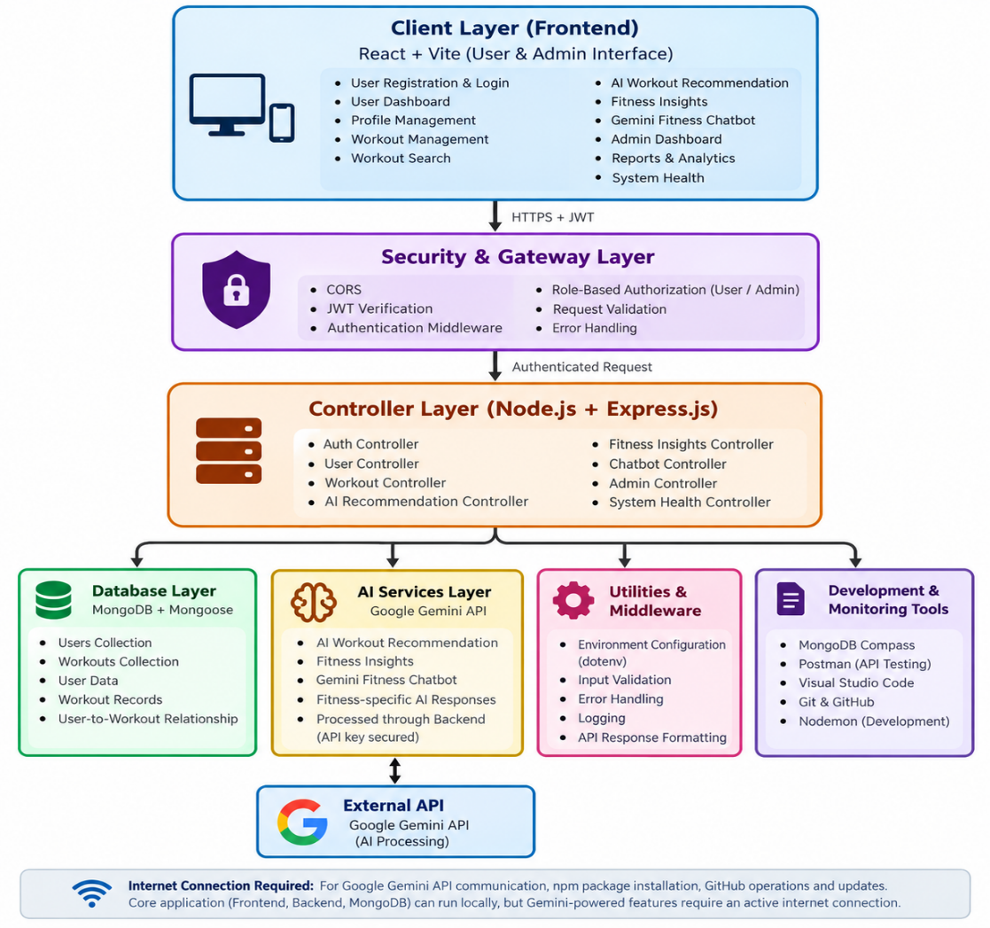
Backend Layer
● Node.js
● Express.js
● RESTful API Architecture
● JWT Authentication
● bcrypt.js Password Hashing
● Authentication Middleware
● Role-Based Authorization for User and Admin
● Centralized Error Handling
● CORS Configuration
● Environment Variable Configuration using dotenv
The backend provides REST APIs for:
● User Registration and Login
● User Profile
● Workout CRUD Operations
● Workout Search
● AI Workout Recommendation
● Fitness Insights
● Gemini Fitness Chatbot
● Admin Dashboard
● Users Monitoring
● Workout Monitoring
● Reports & Analytics
● System Health

Database Layer
● MongoDB Community Server
● Mongoose ODM
● MongoDB Compass for database viewing and management
The primary MongoDB collections used by AI FitTrack are:
● Users Collection
● Workouts Collection
The User and Workout collections follow a one-to-many relationship, where one authenticated user can have multiple workout records.
Mongoose is used for:
● Schema Definition
● Data Validation
● Database Queries
● CRUD Operations
● User-to-Workout Relationship
● Automatic Timestamps
AI FitTrack currently uses the local MongoDB database during development.

AI Layer
● Google Gemini API
● Backend-based Gemini Service Integration
● AI Workout Recommendation
● Fitness Insights
● Gemini Fitness Chatbot
● Fitness-focused Prompt Processing
Google Gemini is accessed through the backend service layer so that the Gemini API key is not exposed directly in the frontend.
The AI layer is used to generate:
● Personalized Workout Recommendations
● Fitness-related Insights
● Exercise Suggestions
● Motivational Guidance
● Fitness Safety Guidance
● Fitness Chatbot Responses
The current AI FitTrack implementation does not include an approved RAG pipeline, embedding model, vector database, or local LLM fallback.

Storage Layer
● MongoDB Persistent Storage
● Users Collection
● Workouts Collection
MongoDB stores the persistent application data required by AI FitTrack.
The Users Collection maintains user account, authentication, and role-related information.
The Workouts Collection maintains workout records belonging to authenticated users.
No separate caching technology such as NodeCache or Redis is confirmed in the current AI FitTrack implementation, so it should not be included as an implemented feature.

Security Layer
● JWT Authentication
● bcrypt.js Password Hashing
● Protected API Routes
● Authentication Middleware
● Role-Based Authorization for User and Admin
● CORS Configuration
● Environment Variable Protection
● Request/Data Validation
● Centralized Error Handling
JWT provides stateless authentication for protected application functionality.
bcrypt.js is used to securely hash user passwords before storage.
Administrative functionality is restricted to authenticated users with the Admin role, while normal users can access only their permitted application features.
Sensitive values such as:
● MongoDB Connection String
● JWT Secret
● Google Gemini API Key
are maintained through environment variables and should not be exposed in frontend code or committed publicly.

ER Diagram

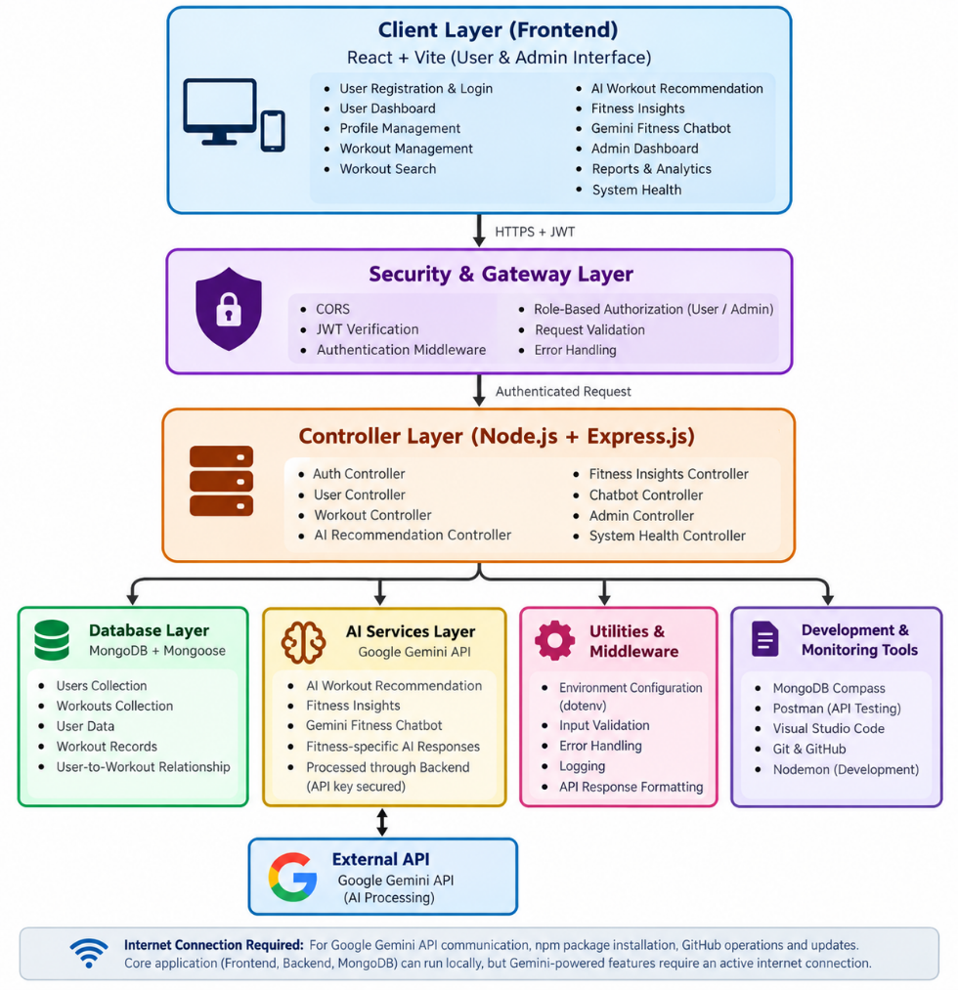

Collections

Users
Stores registered user account, authentication, profile, and role information.
● _id
● name
● email (unique)
● password (bcrypt hash)
● role (user | admin)
● createdAt
● updatedAt
The role field distinguishes normal users from administrators. Admin is not maintained as a separate MongoDB collection.
Workouts
Stores workout records created by authenticated users.
● _id
● user (ref User)
● workoutName
● category
● duration
● caloriesBurned
● workoutDate
● createdAt
● updatedAt
Each workout is associated with one authenticated user through the user reference.
Relationship
User → Workout : One-to-Many (1:N)
One User can create multiple Workout records, while each Workout belongs to one User. The relationship is maintained using the user ObjectId reference in the Workout collection.
AI Workout Recommendation
AI Workout Recommendations are generated through Google Gemini using user-provided fitness information. A separate AI_Recommendation MongoDB collection is not confirmed in the current implementation.
Fitness Insights
Fitness Insights are generated from workout information through the AI service. A separate FitnessInsights collection is not confirmed in the current database schema.
Gemini Fitness Chatbot
The chatbot processes fitness-related messages using Google Gemini. Persistent chatbot history is not stored in MongoDB in the current implementation.
Admin Data
Admin Dashboard, Users, Workout Monitoring, Reports & Analytics, and System Health provide administrative monitoring functionality. These are not documented as separate MongoDB collections unless corresponding models are implemented.
ER Diagram Explanation
The AI FitTrack ER Diagram represents the relationship between the two primary MongoDB collections: Users and Workouts.One User can create and maintain multiple Workout records, while each Workout belongs to only one authenticated User. This forms a One-to-Many (1:N) relationship. The relationship is maintained using the user ObjectId reference stored inside the Workout document. AI FitTrack.docx
The Users collection stores account, authentication, profile, and role information. The role field distinguishes between a normal user and an admin; Admin is not maintained as a separate database collection.
The Workouts collection stores workout information such as workout name, category, duration, calories burned, workout date, and timestamps.AI Workout Recommendations, Fitness Insights, and Gemini Fitness Chatbot responses are generated through the AI service and are not documented as separate persistent MongoDB collections. The verified database scope consists primarily of Users and Workouts. AI FitTrack.docx
Features :
Core Application Features
● User Registration and Login
● JWT Authentication
● bcrypt.js Password Hashing
● Protected Routes
● Authentication Middleware
● User and Admin Role Authorization
● User Profile
● User Dashboard
● Workout CRUD Operations
● Workout Search
● Centralized Error Handling
● RESTful API Communication
● React/Vite Frontend
● MongoDB with Mongoose ODM
● MongoDB Compass for database inspection
● Admin Dashboard
● Users Monitoring
● Workout Monitoring
● Reports & Analytics
● System Health
The core fitness functionality includes authentication, profile retrieval, complete Workout CRUD, workout search, and protected API access. AI FitTrack.docx

AI Features

● AI Workout Recommendation
● AI Fitness Insights
● Gemini Fitness Chatbot
● Personalized workout guidance based on Age, Fitness Goal, and Experience Level
● Workout performance analysis
● Improvement suggestions
● Motivational guidance
● Fitness progress summary
● Fitness-focused chatbot responses
● Safety-oriented fitness guidance

Google Gemini is accessed through the backend service layer to prepare requests, communicate with the AI service, and return generated responses. AI FitTrack.docx

Note: RAG, Vector Search, Embedding Models, local LLM execution, persistent chatbot history, and separate AI response collections are not part of the confirmed current database implementation.

Roles and Responsibilities

Admin

The Admin role provides read-only monitoring functionality.

● Login securely
● Access Admin Dashboard
● View registered Users
● Monitor Workout activity
● View Reports & Analytics
● View System Health
● Monitor application-level information

The Admin role is intended for application monitoring and does not provide unrestricted modification of users' personal workout records.

User

● Register an account
● Login securely
● Access User Dashboard
● View Profile
● Add Workout records
● View Workout history
● Search Workouts
● View individual Workout details
● Update Workout records
● Delete Workout records
● Generate AI Workout Recommendations
● Generate Fitness Insights
● Use Gemini Fitness Chatbot

Workout management and AI-assisted fitness guidance are core user capabilities. AI FitTrack.docx

User Flow

User Registration

User Login

JWT Authentication – authentication token is generated

User Dashboard Access

View Profile / Workout History

Create, View, Update, Delete, or Search Workout records

Workout data stored/retrieved using MongoDB and Mongoose

Request AI Workout Recommendation

Provide Age, Fitness Goal, and Experience Level

Google Gemini generates personalized workout guidance

Generate Fitness Insights from recorded workout activity

Use Gemini Fitness Chatbot for fitness-related assistance

Backend returns the result to the React frontend

Generated information is displayed to the authenticated User

Admin Flow

Admin Login

JWT Authentication

Admin Role Authorization

Admin Dashboard Access

View Users

Monitor Workouts

View Reports & Analytics

View System Health

MVC Pattern

AI FitTrack follows a modular MVC/layered architecture. The backend separates Models, Routes, Controllers, Middleware, Services, and Configuration so that each component performs a dedicated responsibility. AI FitTrack.docx

Model Layer

Responsible for defining and managing persistent application data.

User Model

Responsible for:

● User account information
● Name and Email
● Password storage using bcrypt hash
● User/Admin role
● Authentication-related data
● Timestamps

Workout Model

Responsible for:

● Workout Name
● Category
● Duration
● Calories Burned
● Workout Date
● User reference
● Timestamps

Implemented using Mongoose with MongoDB.

The verified database relationship is User → Workout (1:N). AI FitTrack.docx

Controller Layer

Controllers receive requests from routes, process application logic, communicate with models or services, and return structured responses.

Authentication Controller

Responsible for:

● User Registration
● User Login
● User Profile Retrieval

Workout Controller

Responsible for:

● Creating Workout records
● Retrieving Workout records
● Searching Workouts
● Retrieving Workout by ID
● Updating Workouts
● Deleting Workouts

AI Controller / Service

Responsible for :
● Processing Workout Recommendation requests
● Preparing Gemini prompts
● Sending requests to Google Gemini

● Receiving AI-generated results
● Processing Fitness Insights
● Returning AI responses to the frontend

Chatbot Controller / Service

Responsible for:

● Receiving fitness-related user messages
● Validating chatbot requests
● Communicating with Google Gemini
● Returning fitness-focused responses

Admin Controller

Responsible for retrieving read-only administrative information for:

● Dashboard
● Users
● Workout Monitoring
● Reports & Analytics
● System Health

View Layer / Frontend

The View Layer is implemented using React with Vite.

It provides the user-facing interfaces for:
●Registration
● Login
● User Dashboard
● Profile
● Workout List
● Add Workout
● Workout Details
● Edit Workout
● Workout Search
● Workout Recommendation
● Fitness Insights
● Gemini Fitness Chatbot
● Admin Dashboard
● Users

● Workout Monitoring
● Reports & Analytics
● System Health
The current full-stack scope explicitly includes React/Vite pages for authentication, dashboard, profile, workout management, AI Recommendation, Fitness Insights, and the Gemini Fitness Chatbot. Pasted markdown

Route Layer

The Route Layer defines REST API endpoints and maps incoming requests to the corresponding controllers.

Authentication Routes

● POST /api/auth/register — Register User
● POST /api/auth/login — Login User
● GET /api/auth/profile — Get authenticated User Profile

Workout Routes

● POST /api/workouts — Add Workout
● GET /api/workouts — Get all authenticated User workouts
● GET /api/workouts/search — Search Workouts
● GET /api/workouts/:id — Get Workout by ID
● PUT /api/workouts/:id — Update Workout
● DELETE /api/workouts/:id — Delete Workout

AI Routes

● POST /api/ai/workout-recommendation — Generate Workout Recommendation
● GET /api/ai/fitness-insights — Generate/Retrieve Fitness Insights
These core operations match the verified authentication, workout, and AI capabilities in the project sources. AI FitTrack.docx

Chatbot Route

● POST /api/chatbot — Gemini Fitness Chatbot
The chatbot accepts fitness-related messages and returns a fitness-focused Gemini response.

Admin Routes

The Admin API group provides protected read-only access for:
● Admin Dashboard
● Users
● Workout Monitoring
● Reports & Analytics
● System Health

Use the exact implemented Admin URI strings from the current backend source when listing them in the final API table; the older reference document does not establish those endpoint strings.

Advantages of MVC / Layered Architecture

● Separation of Concerns — Frontend, routes, controllers, services, models, and middleware have separate responsibilities.
● Better Maintainability — Individual modules can be modified without changing the entire application.
● Improved Security — JWT authentication and protected routes are handled through dedicated middleware.
● Reusable Components — Gemini, authentication, workout, and database logic can be reused across application functions.
● Easy Scalability — New functionality can be added through independent modules.
● Team Collaboration — Frontend and backend components can be developed and maintained separately.
● Easier Testing — Authentication, Workout APIs, AI services, chatbot functionality, and Admin features can be tested independently.

Project Setup and Configuration

Project Structure
Create the main project folder AI FitTrack. The application is organized into two major parts:
● backend/ – Node.js + Express.js server application
● frontend/ – React + Vite client application
AI FitTrack/
│
├── backend/
│ ├── src/
│ │ ├── app.js
│ │ ├── server.js
│ │ │
│ │ ├── config/
│ │ │ └── db.js
│ │ │
│ │ ├── controllers/
│ │ │ ├── authController.js
│ │ │ ├── workoutController.js
│ │ │ ├── aiController.js
│ │ │ └── chatbotController.js
│ │ │
│ │ ├── middleware/
│ │ │ ├── authMiddleware.js
│ │ │ └── errorMiddleware.js
│ │ │
│ │ ├── models/
│ │ │ ├── User.js
│ │ │ └── Workout.js
│ │ │
│ │ ├── routes/
│ │ │ ├── authRoutes.js
│ │ │ ├── workoutRoutes.js
│ │ │ ├── aiRoutes.js
│ │ │ └── chatbotRoutes.js
│ │ │
│ │ ├── services/
│ │ │ ├── geminiService.js
│ │ │ └── chatbotService.js
│ │ │
│ │ └── utils/
│ │ └── generateToken.js
│ │
│ ├── tests/
│ ├── .env
│ ├── .env.example
│ ├── .gitignore
│ └── package.json
│
├── frontend/
│ ├── src/
│ │ ├── components/
│ │ ├── hooks/
│ │ ├── pages/
│ │ │ ├── dashboard/
│ │ │ ├── workouts/
│ │ │ ├── ai/
│ │ │ └── profile/
│ │ ├── services/
│ │ └── utils/
│ │
│ └── package.json
│
└── README

Server Setup
Create and initialize the backend:
mkdir backend
cd backend
npm init -y

The backend source is organized into:
● config/
● controllers/
● middleware/
● models/
● routes/
● services/
● utils/
● tests/
The actual backend source confirms app.js, server.js, config/db.js, authentication/workout/AI controllers, middleware, User/Workout models and API routes. Pasted text(20260925-050528)

Install Backend Packages

npm install express mongoose dotenv cors bcryptjs jsonwebtoken

npm install --save-dev nodemon

These packages provide:

● express – REST API server and routing
● mongoose – MongoDB ODM
● dotenv – Environment variable configuration
● cors – Frontend/backend communication
● bcryptjs – Password hashing
● jsonwebtoken – JWT authentication
● nodemon – Development server auto-restart

The reference implementation confirms these backend dependencies and Nodemon development setup.

Environment Variables
Sensitive configuration is maintained through .env.
PORT=5000
MONGO_URI=mongodb://127.0.0.1:27017/aifittrack
JWT_SECRET=your_jwt_secret
GEMINI_API_KEY=your_gemini_api_key
Actual secret values must not be committed to GitHub or exposed through the frontend.

Frontend Setup
The frontend is developed using React with Vite.
The current frontend includes React, React Router and Vite-based development/build scripts. Pasted text(20260926-075157)
Typical setup:
cd frontend
npm install
npm run dev
The frontend communicates with the Express backend through REST APIs and provides the interfaces for authentication, workout management, AI features, profile and administrative functionality.

Backend Development
The AI FitTrack backend provides functionality for:
● User Registration and Login
● JWT Authentication
● User Profile
● Workout CRUD Operations
● Workout Search
● Google Gemini Integration
● AI Workout Recommendation
● Fitness Insights
● Gemini Fitness Chatbot
● Admin Dashboard
● Users Monitoring
● Workout Monitoring
● Reports & Analytics
● System Health
● Centralized Error Handling

REST API Summary
Method | Endpoint | Access | Purpose
POST | /api/auth/register | Public | Create account
POST | /api/auth/login | Public | Login and receive JWT
GET | /api/auth/profile | User | View authenticated user profile
POST | /api/workouts | User | Create workout
GET | /api/workouts | User | View all workouts
GET | /api/workouts/search | User | Search workouts
GET | /api/workouts/:id | User | View workout by ID
PUT | /api/workouts/:id | User | Update workout
DELETE | /api/workouts/:id | User | Delete workout
POST | /api/ai/workout-recommendation | User | Generate AI workout recommendation
GET | /api/ai/fitness-insights | User | Generate fitness insights
POST | /api/chatbot | User | Gemini Fitness Chatbot
GET | /api/admin/dashboard | Admin | View admin dashboard
GET | /api/admin/users | Admin | View registered users
GET | /api/admin/workouts | Admin | Monitor workout records

AI API Explanation – Google Gemini
Purpose: Google Gemini is integrated into AI FitTrack to generate personalized Workout Recommendations, Fitness Insights, and fitness-focused chatbot responses (POST /api/ai/insights, /api/ai/recommendations, /api/ai/ask).
Request Structure: The authenticated client sends fitness-related input with a Bearer JWT. For Workout Recommendation, the request includes Age, Fitness Goal, and Experience Level. The backend validates the input, prepares a fitness-specific Gemini prompt, sends the request through the Gemini service, and returns the generated recommendation.
POST /api/ai/workout-recommendation
Authorization: Bearer <JWT>
Content-Type: application/json

{
"age": 19,
"fitnessGoal": "Fat Loss",
"experienceLevel": "Beginner"
}
Response Structure:
A successful Workout Recommendation response follows this structure:
{
"success": true,
"message": "Workout recommendation generated successfully",
"data": {
"recommendation": "AI-generated personalized workout recommendation"
}
}

The generated recommendation can contain:
● Personalized Workout Plan
● Weekly Exercise Suggestions
● Experience-Level Recommendations
● Motivational Guidance
● Safety Tips
Fitness Insights :
The Fitness Insights API automatically retrieves the authenticated user's workout records and sends the workout information to Gemini for analysis.
GET /api/ai/fitness-insights
Authorization: Bearer <JWT>
Example response:
{
"success": true,
"message": "Fitness insights generated successfully",
"data": {
"workoutCount": 1,
"insights": "AI-generated fitness analysis"
}
}
The generated insights can include:
● Progress Summary
● Consistency Analysis
● Workout Patterns
● Improvement Suggestions
● Motivational Feedback
The verified API test confirms the workoutCount and insights response structure.

Gemini Fitness Chatbot
The chatbot accepts fitness-related questions from authenticated users.
POST /api/chatbot
Authorization: Bearer <JWT>
Content-Type: application/json

{
"message": "Suggest a simple beginner full-body workout."
}

Example response structure:
{
"success": true,
"message": "Fitness chatbot response generated successfully",
"data": {
"response": "AI-generated fitness response"
}
}
The chatbot is restricted to fitness-related areas such as workout recommendations, fitness insights, motivational guidance, and fitness safety guidance. Persistent conversation history is not maintained.

Cost Considerations :
Google Gemini is an external AI service, so API availability and usage limits depend on the configured Gemini account and its applicable quota or pricing plan.
The current AI FitTrack implementation does not confirm:
● NodeCache-based AI response caching
● Paid-call optimization through caching
● Smart fallback AI engine
● Local LLM fallback
Therefore, these unconfirmed cost-reduction mechanisms should not be documented as implemented AI FitTrack features.
Security Practices
● GEMINI_API_KEY is stored on the backend through environment configuration.
● The Gemini API key is never exposed directly in the React frontend.
● Protected AI functionality requires JWT authentication.
● AI requests pass through the backend before reaching Google Gemini.
● Environment secrets such as GEMINI_API_KEY, JWT_SECRET, and MONGO_URI must not be committed publicly.

Database Development

MongoDB Collections & Relationships
Collection | Key fields | Relationship
users_id, name, email, password, role, createdAt, updatedAt1 → N Workouts | users_id, name, email, password, role, createdAt, updatedAt1 → N Workouts | users_id, name, email, password, role, createdAt, updatedAt1 → N Workouts
workouts | _id, user, workoutName, category, duration, caloriesBurned, workoutDate, createdAt, updatedAt | N → 1 User

Users Collection
Stores registered user account and authentication information.
● _id
● name
● email – unique
● password – bcrypt hash
● role – user or admin
● createdAt
● updatedAt
Workouts Collection
Stores workout records belonging to authenticated users.
● _id
● user – ObjectId reference to User
● workoutName
● category
● duration
● caloriesBurned
● workoutDate
● createdAt
● updatedAt
Relationship
User → Workout : One-to-Many (1:N)
One User can have multiple Workout records, while each Workout belongs to one authenticated User.
MongoDB Indexes
AI FitTrack currently uses standard MongoDB/Mongoose indexes.
User Index
● email – Unique index
Workout Indexes
● { user: 1, workoutDate: -1 }
● { user: 1, category: 1 }
● { user: 1, workoutName: 1 }

Atlas Search Index / Vector Search Index

The current AI FitTrack implementation does not define:

● MongoDB Atlas Search
● MongoDB Atlas Vector Search
● Embedding storage
● Vector database
● RAG-based retrieval

AI FitTrack currently uses standard MongoDB queries and indexes.

These capabilities should therefore not be documented as implemented features.

Sample Documents :
Users
{
"_id": ObjectId("..."),
"name": "Demo User",
"email": "user@aifittrack.com",
"password": "$2b$...bcrypt-hash...",
"role": "user",
"createdAt": ISODate("2026-09-25T10:00:00Z"),
"updatedAt": ISODate("2026-09-25T10:00:00Z")
}

Workouts
{
"_id": ObjectId("..."),
"user": ObjectId("..."),
"workoutName": "Morning Running",
"category": "Cardio",
"duration": 30,
"caloriesBurned": 250,
"workoutDate": ISODate("2026-09-25T07:00:00Z"),
"createdAt": ISODate("2026-09-25T08:00:00Z"),
"updatedAt": ISODate("2026-09-25T08:00:00Z")
}

AI Data Handling
AI Workout Recommendation
Workout Recommendations are generated using Google Gemini from:
● Age
● Fitness Goal
● Experience Level
The generated recommendation is returned to the frontend and is not documented as a separate MongoDB collection. Pasted markdown
Fitness Insights
Fitness Insights are generated from the authenticated User's stored Workout records. The backend retrieves the workouts and passes them to the Gemini service for analysis.
Gemini Fitness Chatbot
The chatbot returns fitness-related responses through the backend.
Database Scope Summary
AI FitTrack MongoDB
│
├── users
│ └── User account and authentication data
│
└── workouts
└── User-owned workout records

Project Execution
Step 1: Backend
Open the AI FitTrack backend folder and install the required dependencies.
cd backend
npm install
The backend uses Node.js, Express.js, MongoDB/Mongoose, JWT, bcrypt.js, CORS, environment configuration and Google Gemini integration.
Step 2: Configure Environment Variables

Create a .env file inside the backend/ folder. Real secrets must never be committed to the repository.
PORT=5000
MONGO_URI=mongodb://127.0.0.1:27017/aifittrack
JWT_SECRET=your_secret_key
GEMINI_API_KEY=your_gemini_api_key

Step 3: Run Backend
npm start

Backend URL: http://localhost:5000 (API base: http://localhost:5000/api)
For development:
npm run dev

Output Screenshots with Explanation

API Testing
Explanation:
Backend contract verification confirms authentication, workout CRUD and search, Gemini flows, Admin RBAC, chatbot security, sensitive-data protection, and frontend route guards.
Run this command:
cd "C:\Users\jhath\OneDrive\Documents\AI FitTrack\backend"

npm run verify:v1.2

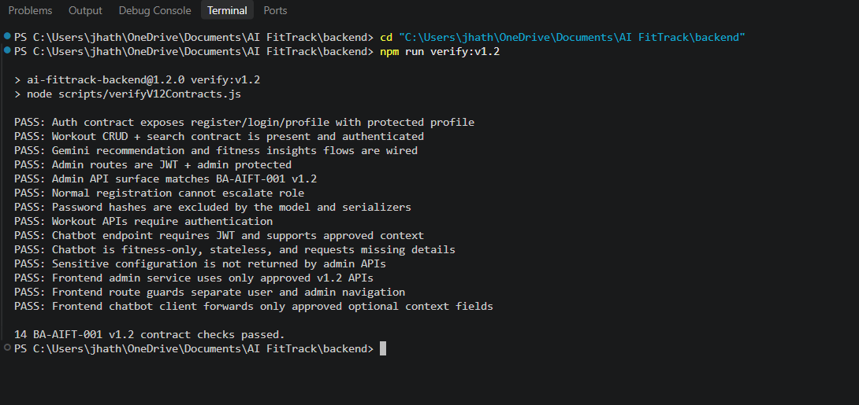

LLM Integration
Explanation:
Google Gemini integration was verified through the AI Workout Recommendation API. The backend receives fitness profile inputs and returns personalized workout guidance generated through Gemini.

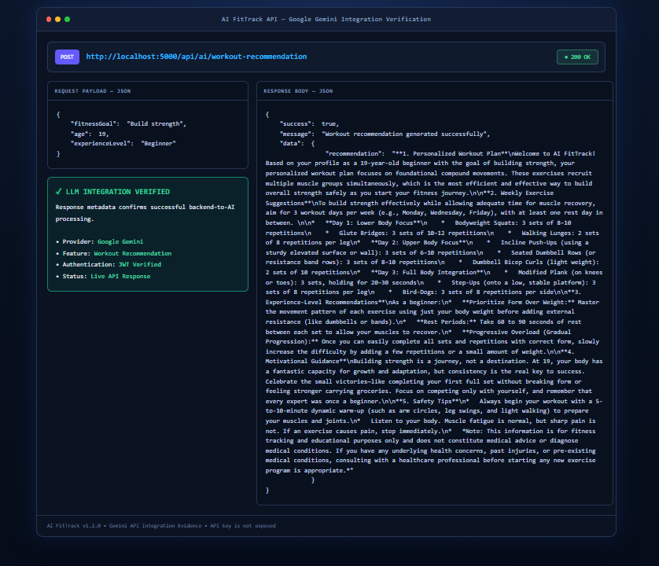

AI Chat Interface
The AI FitTrack Gemini Fitness Chatbot answers fitness-related questions and provides workout guidance, motivation, and safety support
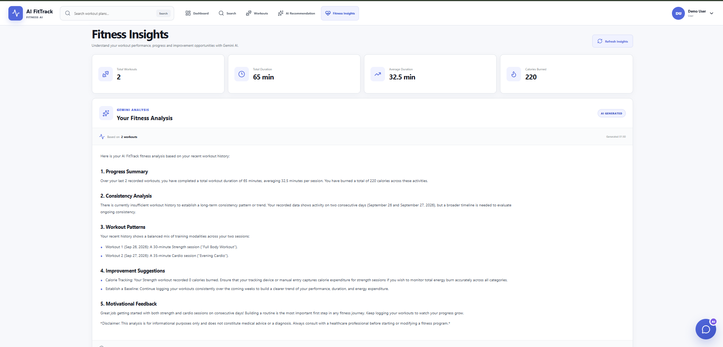

Document Upload

Not applicable – document upload is not implemented in AI FitTrack.

Search Results

AI FitTrack allows users to search their recorded workouts and retrieve matching workout details such as workout name, category, duration, calories burned, and workout date.

Screenshot: Workout Search page showing the search query and matching workout results.

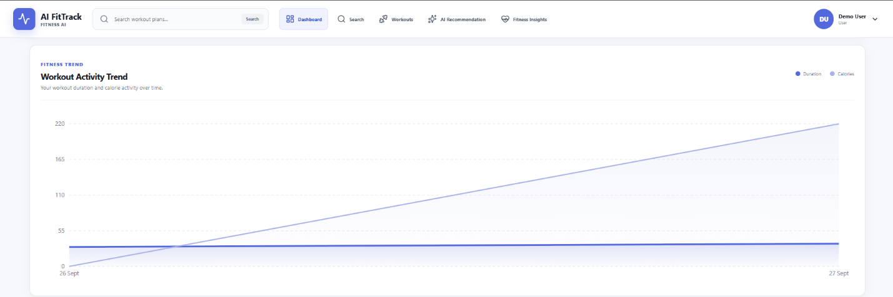

Recommendation Engine
AI FitTrack uses Google Gemini to generate personalized workout recommendations based on the user’s age, fitness goal, and experience level.
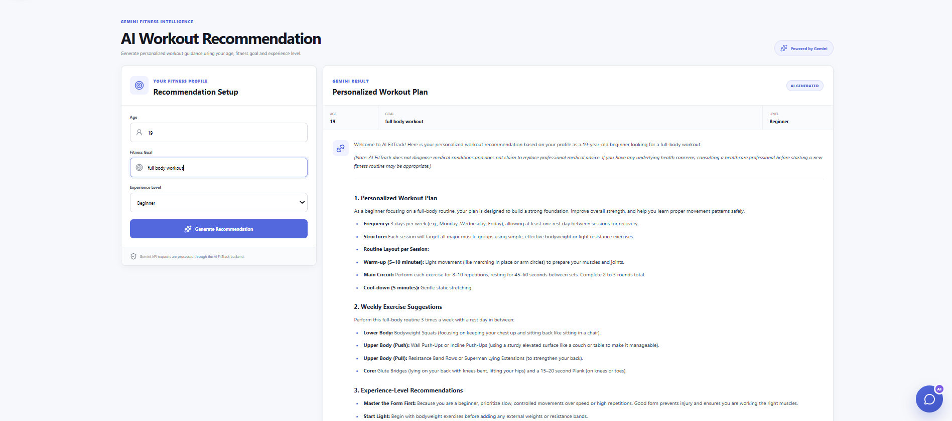

Demo Video Link
Add Demo Video URL: https://drive.google.com/file/d/1iuvzKt5IuI1kRZC60ECMvvIwr1iPTI5h/view?pli=1

Source Code Drive Link

GitHub Repository :
https://github.com/Hatheem-J/AI-FitTrack-Project

Mandatory Functionalities

# | Requirement | Status in repository | Evidence / Note
1 | MVC / Layered Architecture | Implemented. | Models, Controllers, Routes, Middleware, Services and Configuration are separated.
2 | JWT Authentication | Implemented | JWT authentication, bcrypt.js password hashing and authentication middleware protect secured APIs. Pasted markdown
3 | Semantic Search | Implemented | Gemini embeddings generated; semantic endpoint live response; vector-ranked results
4 | MongoDB Atlas Search | Implemented | workout_text_search index READY, QUERYABLE: true; live atlas-search response
5 | MongoDB Atlas Vector Search | Implemented | workout_vector_search index READY, QUERYABLE: true; 768-dim embeddings; live atlas-vector results
6 | Prompt Engineering | Implemented | Gemini service prepares fitness-specific prompts for Workout Recommendations, Fitness Insights and chatbot responses.
7 | AI API Integration | Implemented | Google Gemini is integrated through the backend service layer for Workout Recommendations, Fitness Insights, and the Gemini Fitness Chatbot.
8 | Role-Based Access Control | Implemented | Current AI FitTrack baseline supports User and Admin authorization; Admin functionality is limited to monitoring such as Users, Workouts, Reports & Analytics and System Health.

